Kode oppg1 (a-c)

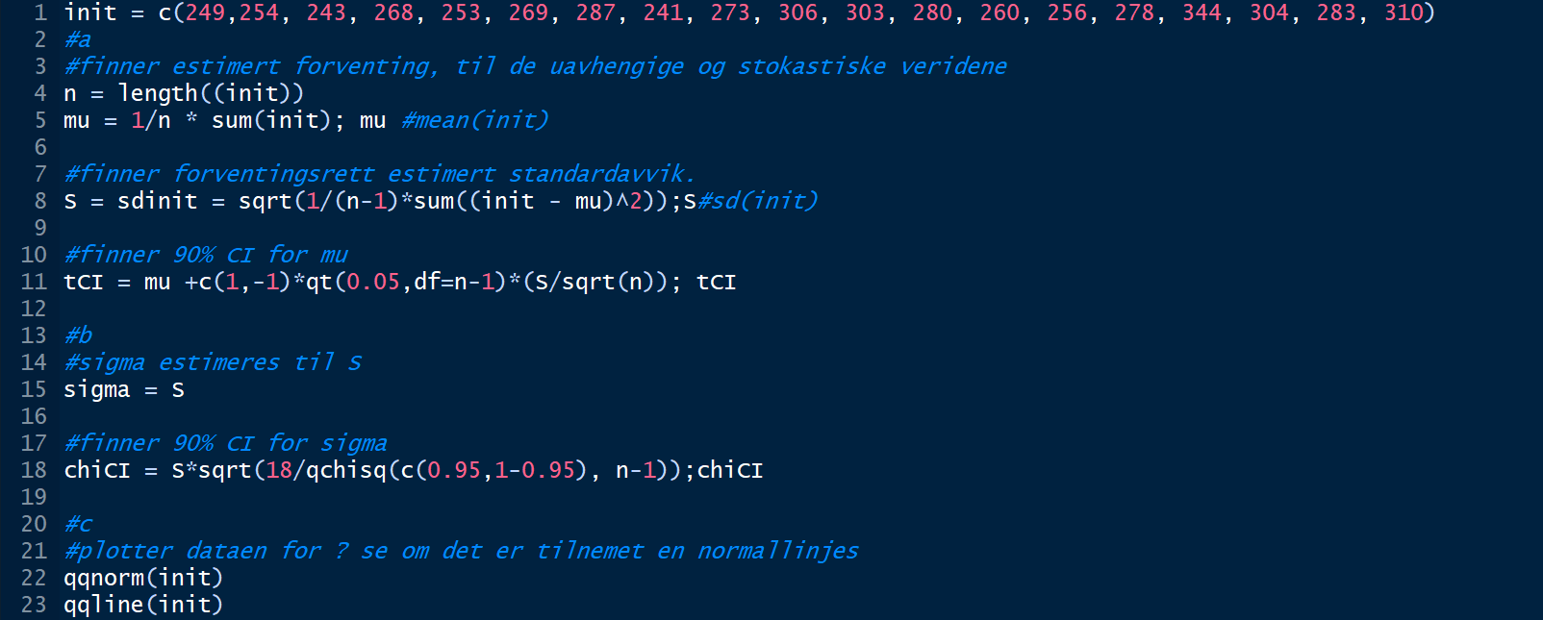

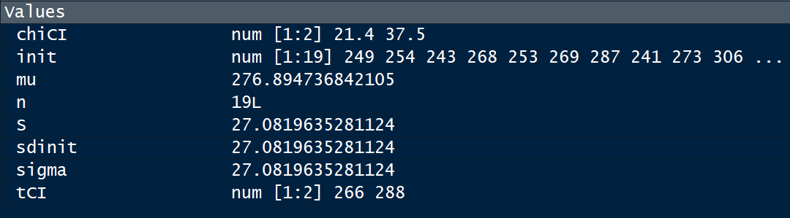

chiCI: 90% konfedensintervall for sigma, init: inndaten, mu: Gjennomsnitt, n: anttall verdier i init, S: estimert standardavvik, sdinit = S, sigma = S = sdinit, 90% konfedensintervall for my.

Plot 1

Et bilde som inneholder kart

Beskrivelse som er generert med svært høy visshet

Oppg2

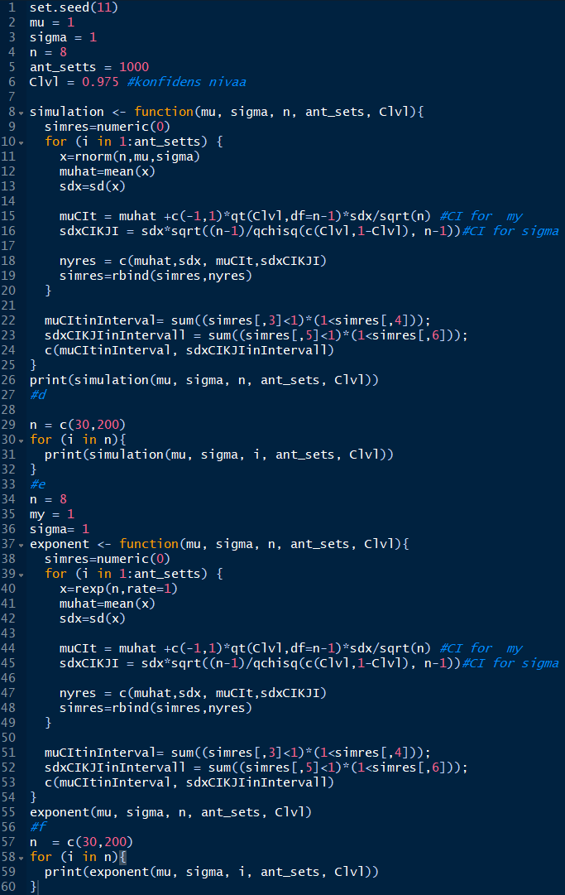

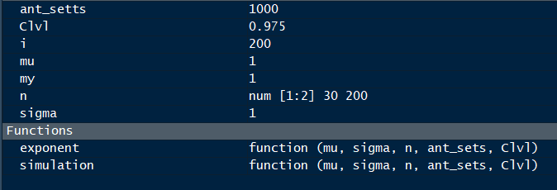

Kjøreeksempel

> set.seed(11)

> mu = 1

> sigma = 1

> n = 8

> ant_setts = 1000

> Clvl = 0.975 #konfidens nivaa

>

> simulation <- function(mu, sigma, n, ant_sets, Clvl){

+ simres=numeric(0)

+ for (i in 1:ant_setts) {

+ x=rnorm(n,mu,sigma)

+ muhat=mean(x)

+ sdx=sd(x)

+

+ muCIt = muhat +c(-1,1)*qt(Clvl,df=n-1)*sdx/sqrt(n) #CI for my

+ sdxCIKJI = sdx*sqrt((n-1)/qchisq(c(Clvl,1-Clvl), n-1))#CI for sigma

+

+ nyres = c(muhat,sdx, muCIt,sdxCIKJI)

+ simres=rbind(simres,nyres)

+ }

+

+ muCItinInterval= sum((simres[,3]<1)*(1<simres[,4]));

+ sdxCIKJIinIntervall = sum((simres[,5]<1)*(1<simres[,6]));

+ c(muCItinInterval, sdxCIKJIinIntervall)

+ }

> print(simulation(mu, sigma, n, ant_sets, Clvl))

[1] 940 952

> #d

>

> n = c(30,200)

> for (i in n){

+ print(simulation(mu, sigma, i, ant_sets, Clvl))

+ }

[1] 946 942

[1] 960 955

> #e

> n = 8

> my = 1

> sigma= 1

> exponent <- function(mu, sigma, n, ant_sets, Clvl){

+ simres=numeric(0)

+ for (i in 1:ant_setts) {

+ x=rexp(n,rate=1)

+ muhat=mean(x)

+ sdx=sd(x)

+

+ muCIt = muhat +c(-1,1)*qt(Clvl,df=n-1)*sdx/sqrt(n) #CI for my

+ sdxCIKJI = sdx*sqrt((n-1)/qchisq(c(Clvl,1-Clvl), n-1))#CI for sigma

+

+ nyres = c(muhat,sdx, muCIt,sdxCIKJI)

+ simres=rbind(simres,nyres)

+ }

+

+ muCItinInterval= sum((simres[,3]<1)*(1<simres[,4]));

+ sdxCIKJIinIntervall = sum((simres[,5]<1)*(1<simres[,6]));

+ c(muCItinInterval, sdxCIKJIinIntervall)

+ }

> exponent(mu, sigma, n, ant_sets, Clvl)

[1] 899 787

> #f

> n = c(30,200)

> for (i in n){

+ print(exponent(mu, sigma, i, ant_sets, Clvl))

+ }

[1] 932 714

[1] 950 686

> View(exponent)

> View(exponent)